In class work 3
- The front entrance to Old Main appears to be a rectangle with a semicircle (one half of a circle) on top. Using a tape measure, it was discovered that the base of the rectangle is 14 feet long and the height of the rectangle is 9 feet tall.

What is the area of the entrance?
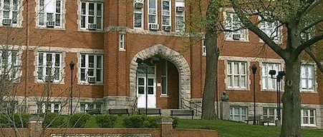

- Simplify.
  - $\left(2x+3\right)(x-2)$
  - $\left(2x-3\right)(x^{2}+x+1)$

- Factor.
  - $8x-4$
  - $9x^{2}-6x+3x-2$
  - $x^{2}-36$
  - $x^{2}+5x+4$
  - $2x^{2}-5x-3$

