Homework 12 Name: ____________________
- Suppose that the graph below measures the points of a particular stock over the time period indicated. Indicate where the places the point-values increase and decrease by drawing directly onto the graph where this occurs. Place your final markings on the x-axis of the graph.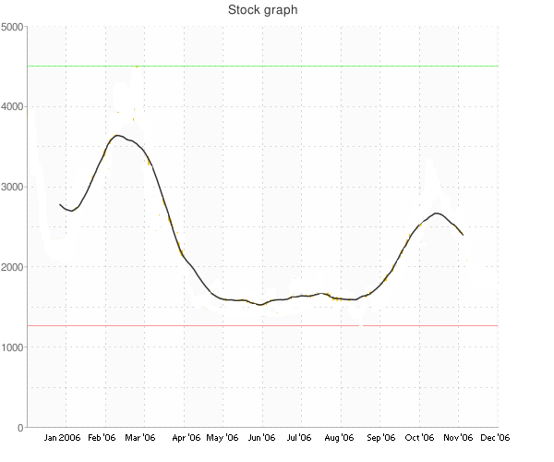

- Tell me whether the following functions are odd, even, or neither.

  - $f\left(x\right)= 4x^{3}$

  - $g\left(x\right)= 11x^{2}+ 2$

  - $G\left(x\right)= 14x^{4}+1.222222031x^{2}$

  - $h\left(x\right)= 12$

